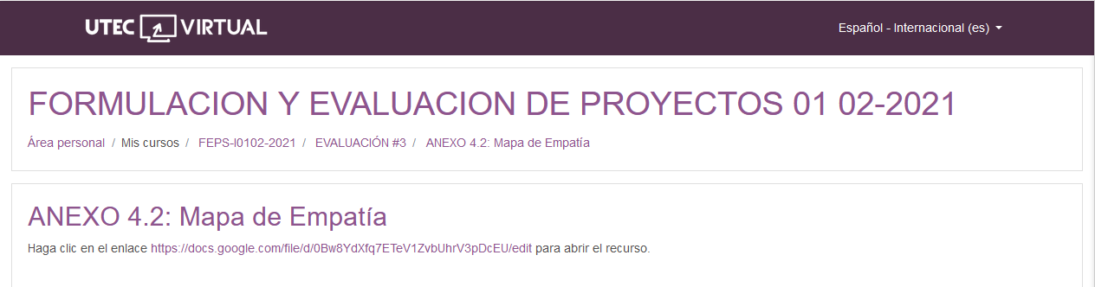

<https://docs.google.com/file/d/0Bw8YdXfq7ETeV1ZvbUhrV3pDcEU/edit?resourcekey=0-gCY3lAUcW9i1RbEXdn3igw>

<https://docs.google.com/file/d/0Bw8YdXfq7ETeV1ZvbUhrV3pDcEU/edit>